Guidelines for Preparation of Digests for OIPE 2027
First AUTHOR*, Second AUTHOR** and Third AUTHOR*
* Institution/Organization, postal address, City, Country
E-mail: oipe2027@ing.unipi.it
** Institution/Organization, postal address, City, Country
E-mail: author@email.com
Abstract. The present sample contains information on preparation of the digests for the 18th International Workshop on Optimization and Inverse Problems in Electromagnetism, OIPE 2027, to be held from September 05 – 09, 2027, in Pisa, Italy. The abstract should contain the most important information about the paper. Also please avoid citations and symbols other than normal text.
Keywords: Up to five, in alphabetical order.

INTRODUCTION
This guide is written using Microsoft Word. It can be downloaded from the home page of the symposium oipe2027.ing.unipi.it. You may type over sections of the present file, cut and paste into it (Edit | Paste Special | Unformatted Text), and/or use markup styles. The length of the digest should be 2 pages. The page setup should be in such a way that on A4 paper the margins are: top margin 2.54 cm, bottom margin 2.54 cm, left margin 2.54 cm and right margin 2.54 cm. Please skip the pages numbering. The proceedings will be printed in A4 format.
PAPER ATTRIBUTES
Fonts and styles
This template provides authors with most of the formatting specifications needed for preparing electronic versions of their papers. All standard paper components have been specified for three reasons: (1) ease of use when formatting individual papers, (2) automatic compliance to electronic requirements that facilitate the concurrent or later production of electronic products, and (3) conformity of style throughout conference proceedings. Margins, column widths, line spacing, and type styles are built-in. The title, authors, affiliation, paragraph headings, table captions and figure captions are centred. The default style, Paper - Paragraph are justified. Section headings are left aligned.
Figures, tables and equations
The creation of tables can be done using “Table | Insert table” command. It is not recommended to split the table over two pages. Table caption should be above the table, as in Table 1.
Table 1: This is the table caption (use style: Paper – Figure).
Style | Font Size | Appearance | Space before | Space after
Paper - Title | 12 | Bold | 6 pt | 9 pt
Paper – Author | 10 | Bold | 6 pt | 0
Paper – Affiliation | 9 | Italic | 12 pt | 16 pt
Paper – Paragraph | 10 | Normal | 6 pt | 6 pt
Paper – Paragraph Heading | 10 | Bold, Small Caps | 0 | 0
Paper – Section Heading | 10 | Bold | 0 | 0
Paper – Figure | 9 | Italic | 0 | 0

Figures should be centred and figure captures placed below the figures, as in Figure 1. In case of very small figures, where text wrapping is necessary, figures can be placed either left or right. It is recommended that the box “Float over text” for the figure position be not checked.

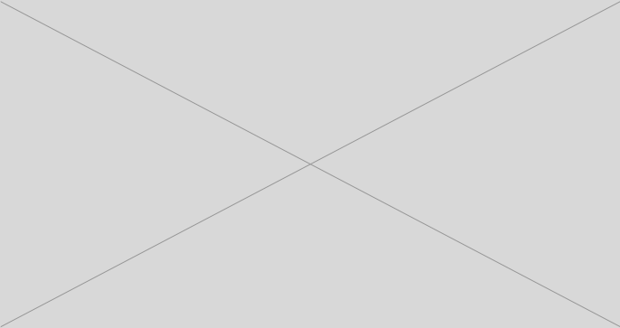
Figure 1: This is the figure caption for centred figure (use style: Paper – Figure).
Equations should be centred and numbered flush left, as in Eqn. 1. They can be part of the sentence, like in the electromagnetic field equation written in the form
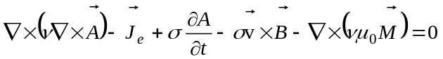. (1)
All symbols used in the equations should be defined either before or right after the equation.
References
All references should be numbered in square brackets both in the list of references and when citing them [1]. For books [2], use italic for the book title. When the book or paper is not in English, give the English translation of the title and specify the language in parentheses at the end.
CONCLUSIONS
Please pay attention to the language. If your native language is not English, please get a native English-speaking colleague to proofread your paper. Employing UK spell checker is recommended.
REFERENCES
- F. Author, S. Author and T. Author. Title of paper with only first letter capitalised. Journal name or conference proceedings, vol. 1, 2008, pp. 196-203.
- M. Young. The Technical Writer's Handbook. Mill Valley. CA, University Science, 1989.

